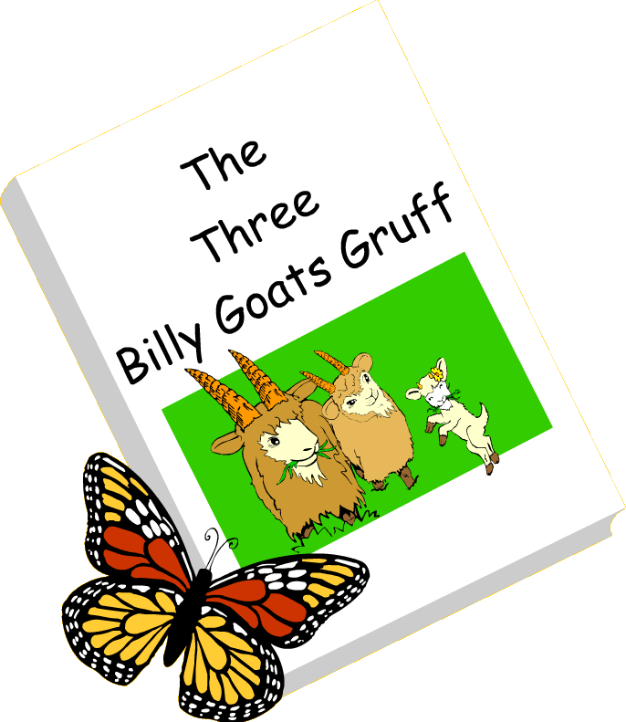

The Three Billy Goats Gruff
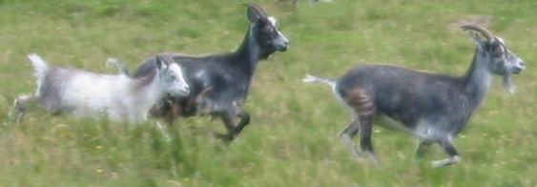

In the Cheviot Hills, there is a valley called College Valley where wild goats live.
If you are lucky and if you walk into the valley quietly and look very hard, you might see them.
You could also smell them too, as they have a VERY strong smell.

This story takes place at a bridge over the College Burn at a waterfall called Hethpool Linn.
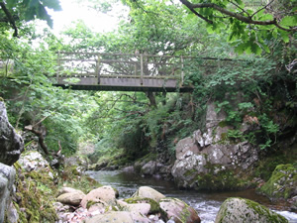
You can walk in the valley and over the same bridge in the story.
You can see where the troll lived (although I think his door is covered with ivy now).
The sides of the bridge are fenced in so you can walk over safely. You can look for the little hole in the tree where the mouse lived.
I hope you get to visit this special place and get to go 'trip trap trip trap' over the bridge.
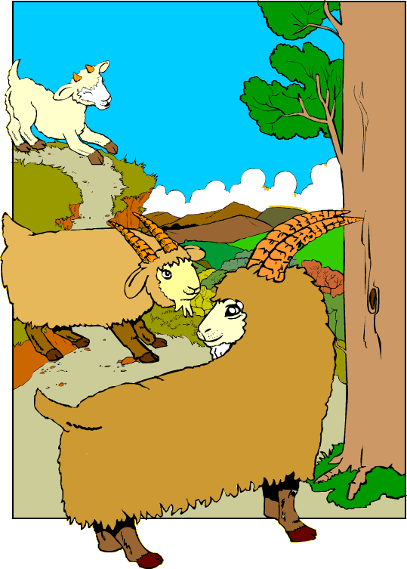
Once upon a time, there were
three Billy Goats Gruff. They lived in a little valley in the hills.

One day, they saw a beautiful
field of sweet green grass on
the other side of the valley.

They wanted to go there.

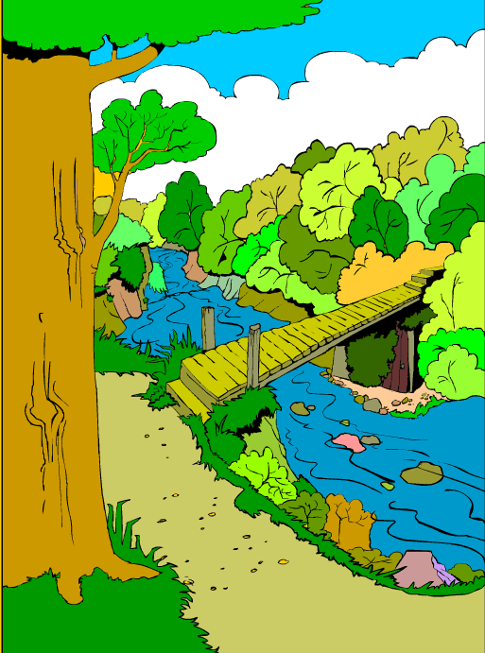
The banks of the river were steep.

The Billy Goats wanted to cross
the little wooden bridge.

A mouse peeped out of a hole
in a tree.

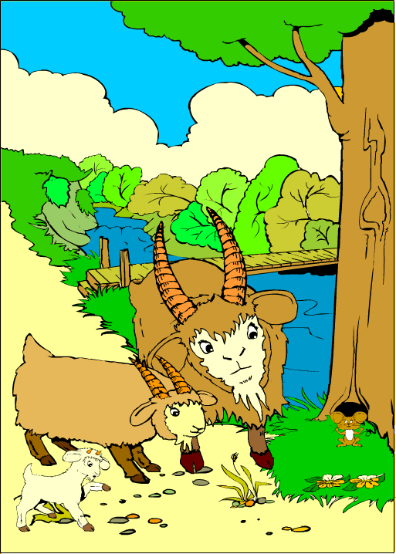
"Be careful," he said to the goats. "A big ugly troll lives under the bridge. If you try to cross, he will catch you and eat you!"

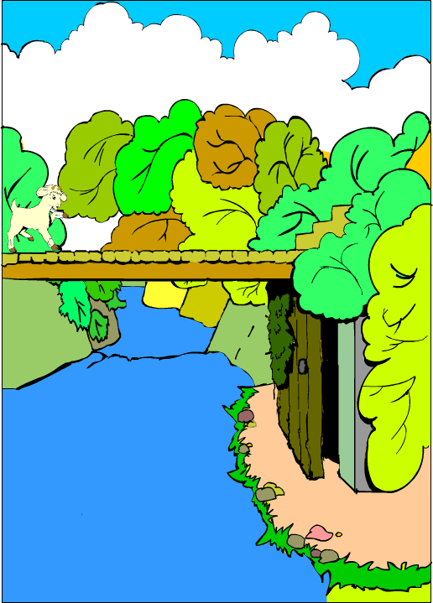
But the goats made a plan.
The smallest Billy Goat Gruff set off to cross the bridge.

His little hooves went trip trap trip trap.

A door under the bridge opened and a big ugly troll came out.
"Who goes trip trap trip trap across my bridge?" he roared.

"It's only me, Little Billy Goat Gruff," said the smallest goat.

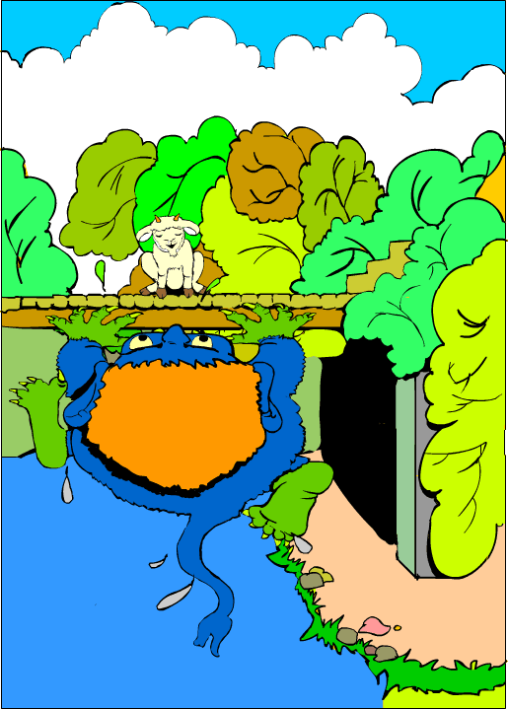
"Then I am coming to eat you up!" roared the troll.

"Oh, don't eat me, I'm much too little," said the smallest Billy Goat Gruff.

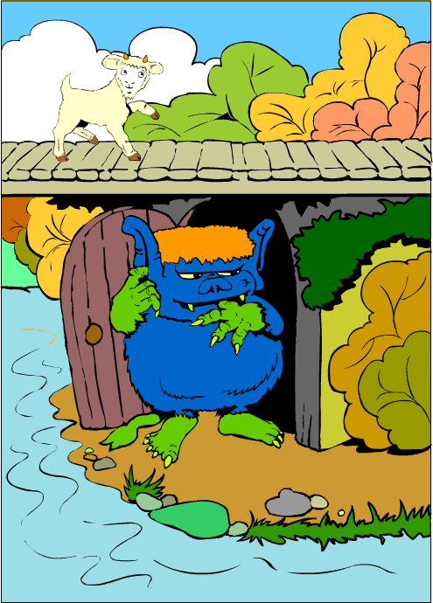
"My brother is coming after me and he is MUCH bigger."

"Hmm," grunted the troll.
"Then I will wait for him."

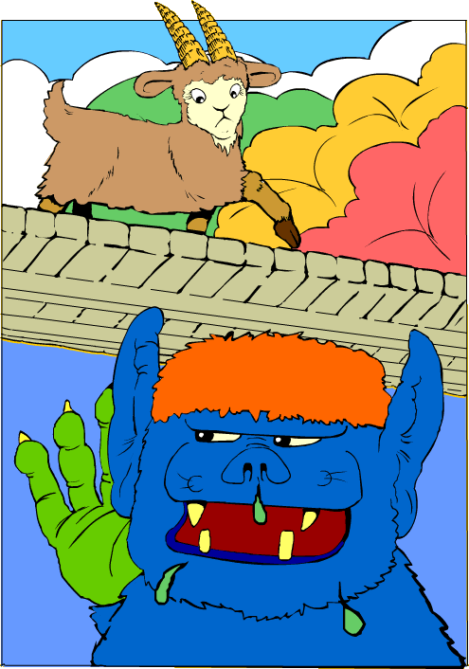
Soon Middle Sized Billy Goat Gruff came over the bridge.

Trip trap trip trap went his hooves.

"Who goes trip trap trip trap across my bridge?" roared the troll.

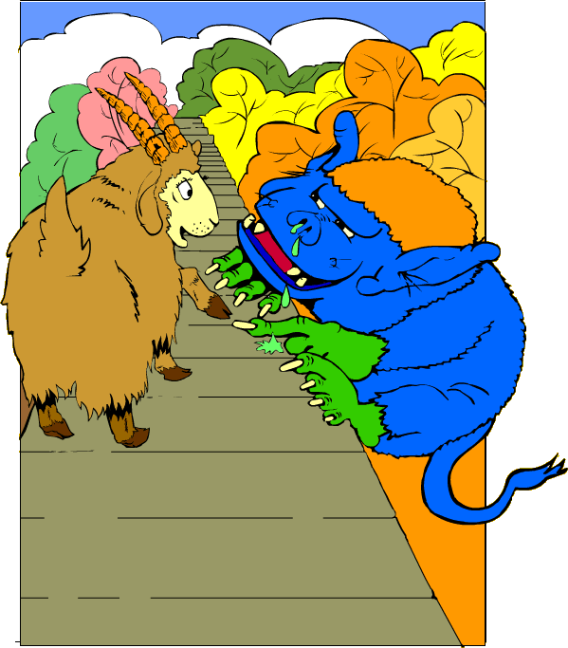
"Oh, it's only me, Middle Sized Billy Goat Gruff," said the goat.
"Then I am coming to eat you up!" roared the troll.
"Oh, don't eat me, I'm much too small," said Medium Sized Billy Goat Gruff. "My brother is coming after me and he is MUCH bigger."
"Hmm, then I will wait for him," grunted the troll.

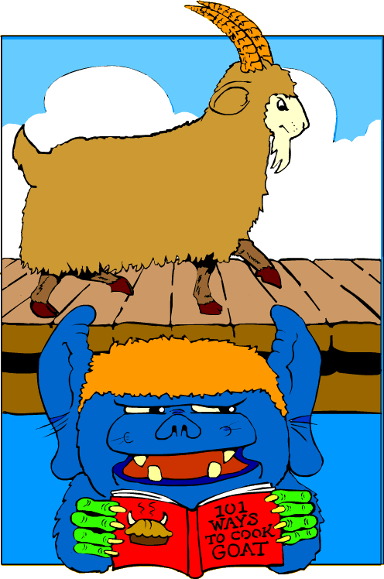
Soon the biggest Billy Goat Gruff came over the bridge.

Trip trap trip trap went his hooves.

"Who goes trip trap trip trap across my bridge?" roared the troll.

"It is I, Great Big Billy Goat Gruff," said the biggest goat.

"Then I am coming to eat you up!" roared the troll.

"Come on up, then!" yelled Great Big Billy Goat Gruff.
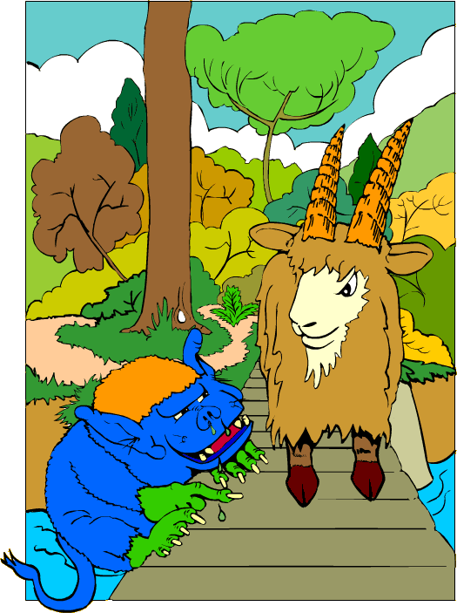

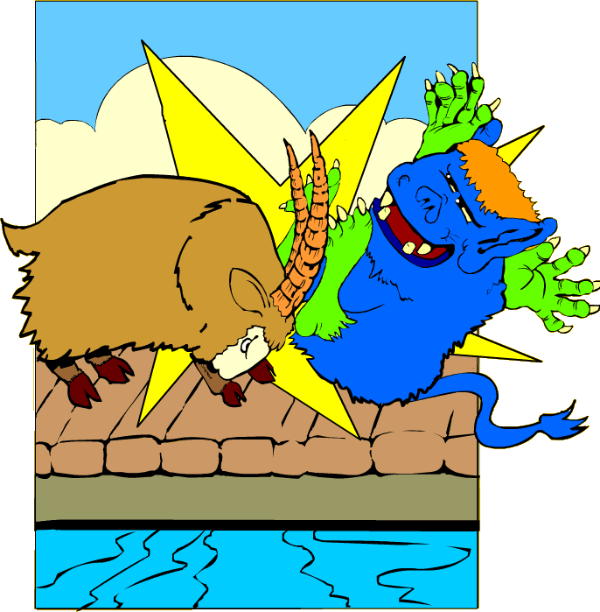

Great Big Billy Goat Gruff was strong.

He put his head down and butted the ugly troll right off the bridge.

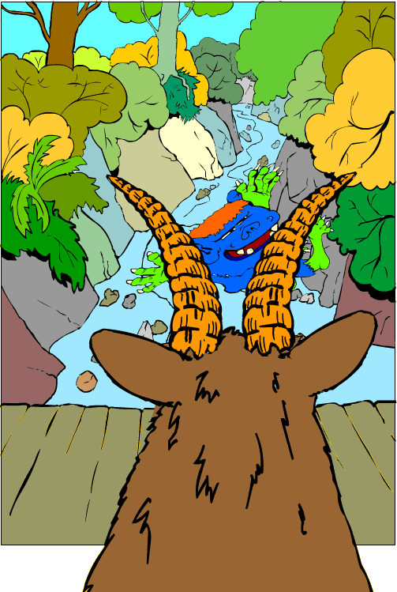

The troll fell into the river and was carried away.

He was never seen again.

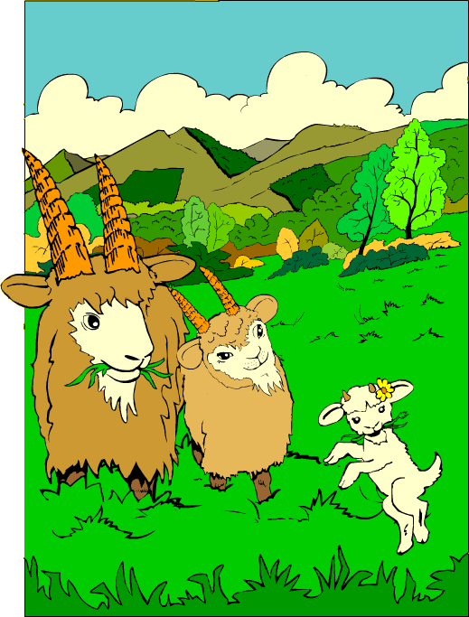

The three Billy Goats Gruff found their field of sweet green grass and ate their fill.

Maybe they are still there today.

